Create valid contact

→ Expected 201

Steps:
Open:
http://3.137.137.62:8000/docs
Click POST /contacts
Click Try it out
Enter:
{
"name": "Alice",
"email": "a@b.com"}
Click Execute

Expected:
Response Code: 201
Response Body with an id:
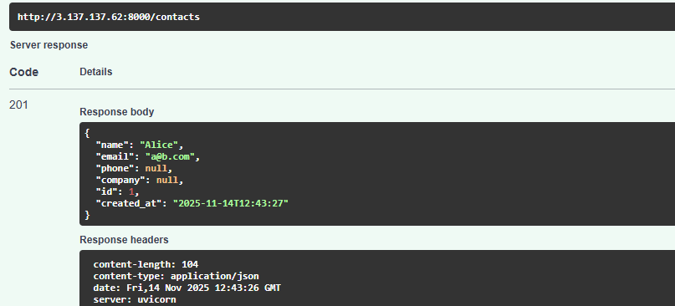

2️⃣ Missing name

→ Expected 422

Steps:
Use the same POST /contacts, but enter:
{
"email": "x@y.com"}

Expected:

Response Code: 422 Unprocessable Entity
Error message showing "name" field is missing
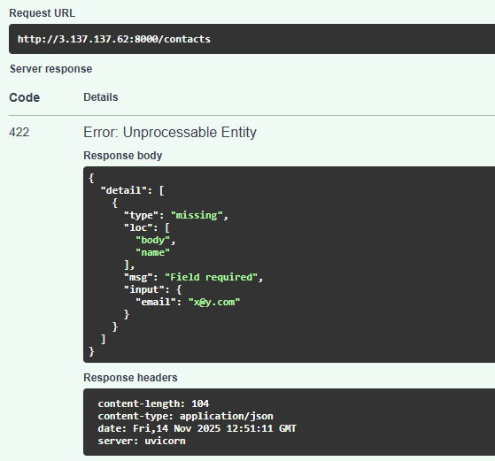

3️⃣ Invalid email

→ Expected 422

Test input:
{
"name": "A",
"email": "abc"}

Expected:
Response Code: 422
Message: value is not a valid email address
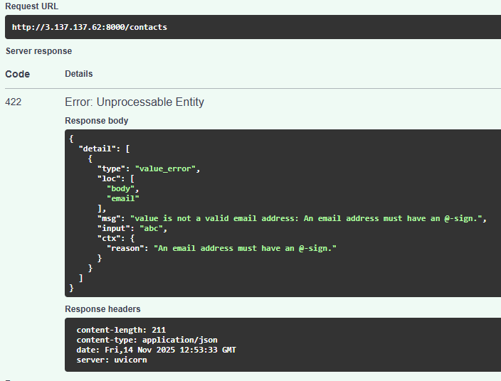

4️⃣ Duplicate email

→ Expected 409

Steps:
First create this contact:

{
"name": "John",
"email": "duplicate@test.com"}
→ Response 201
Try creating it again:
{
"name": "John",
"email": "duplicate@test.com"}

Expected:
Response Code: 409 Conflict
Message: "Email already exists"
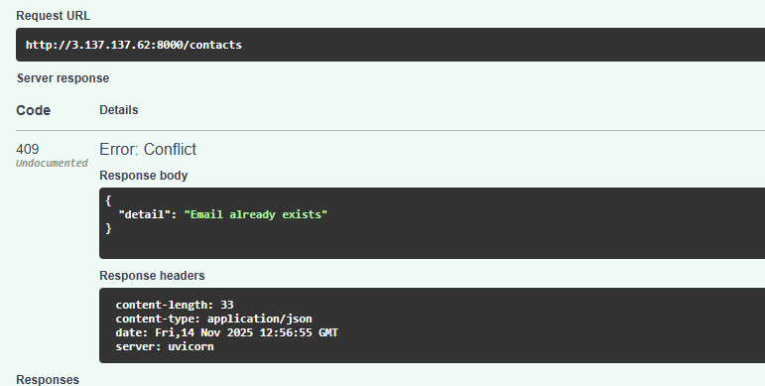

GET /contacts?company=Acm

Open GET /contacts

Click Try it out

In the query fields, fill only:

company: Acme
limit: leave default
offset: leave default

Click Execute

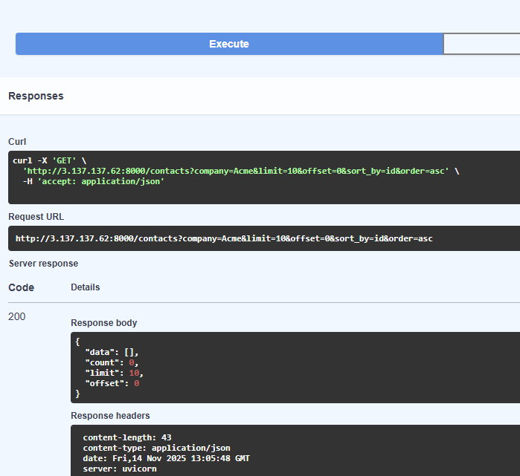

Pagination | limit=5&offset=5 works

This will fetch rows 6–10 (assuming ordering is consistent).
